How People Use Water
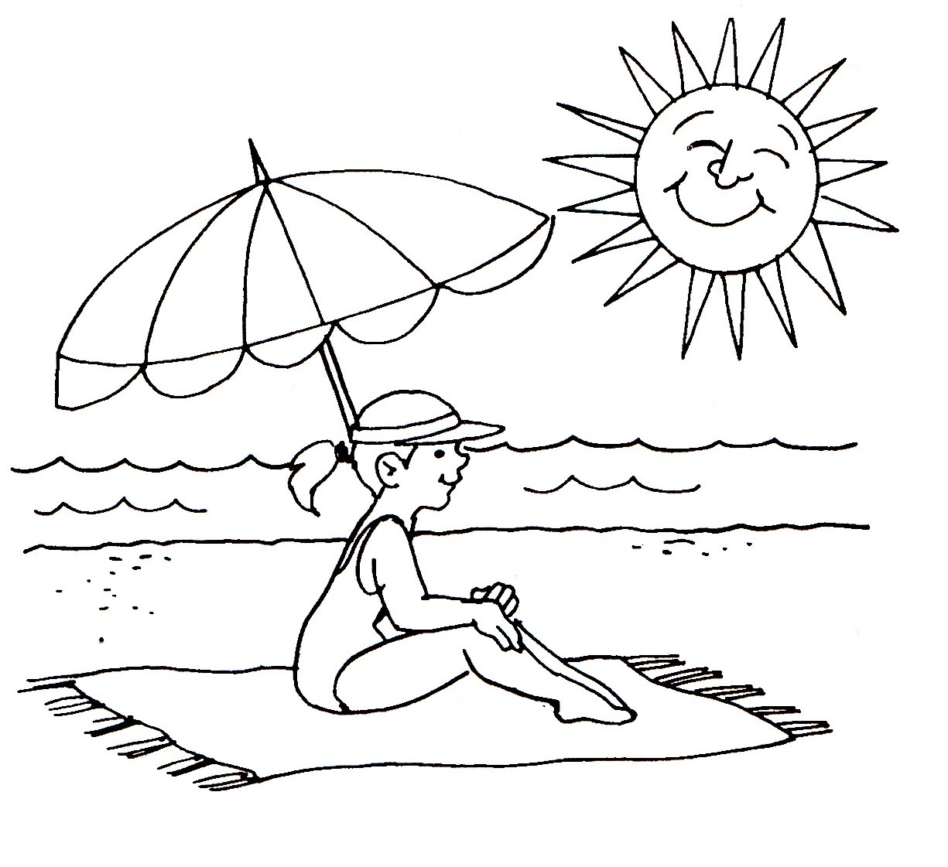
Everybody uses water.

Some people sail their
boats on the water.

A fireman gets water
from a big hose. He
uses the water to put
out fires.

We go to the beach
to swim or surf in the
water.

Comprehension – Answer the questions.
1. What do people sail on the water? ____________________________________________
2. What do you at the beach? __________________________________________________
3. What does a fireman use water for? ___________________________________________

Yes or No?
4. A fireman gets water from a tap. ______________________
5. You can surf at the beach. ______________________
6. You sail your boat on the sand. ______________________

