Spiders

1. Read Spiders by Donna Lyoyd, then label the spider parts and its trap.
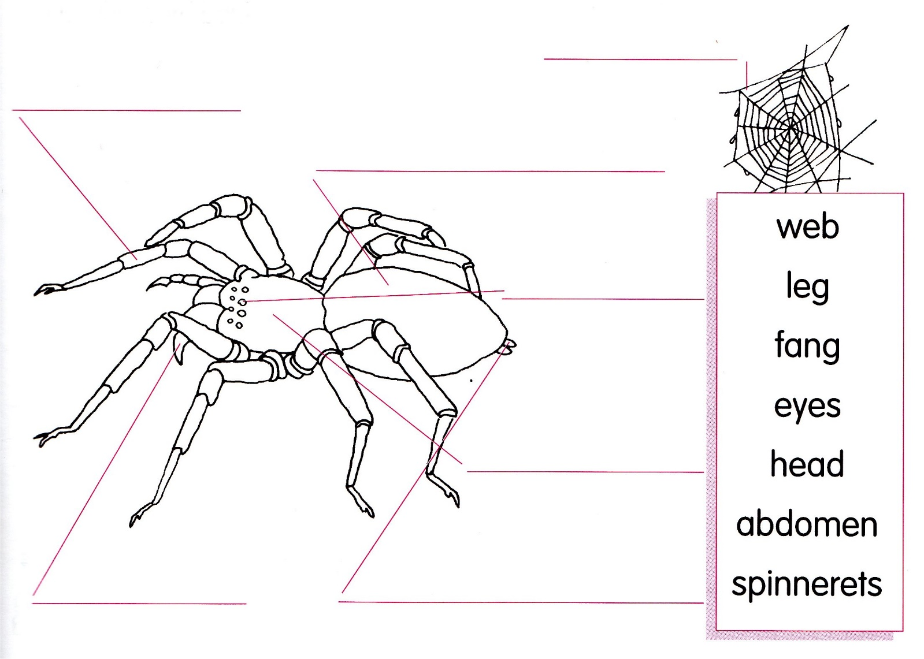
Use the word bank.
2. Use some of the words in the bank to help write a story about spiders.
A spider has a __________________ and __________________.
It has eight __________________.
Most spiders have eight __________________ too.
The __________________ holds the spider’s poison.
The spinnerets are used to make its __________________.

