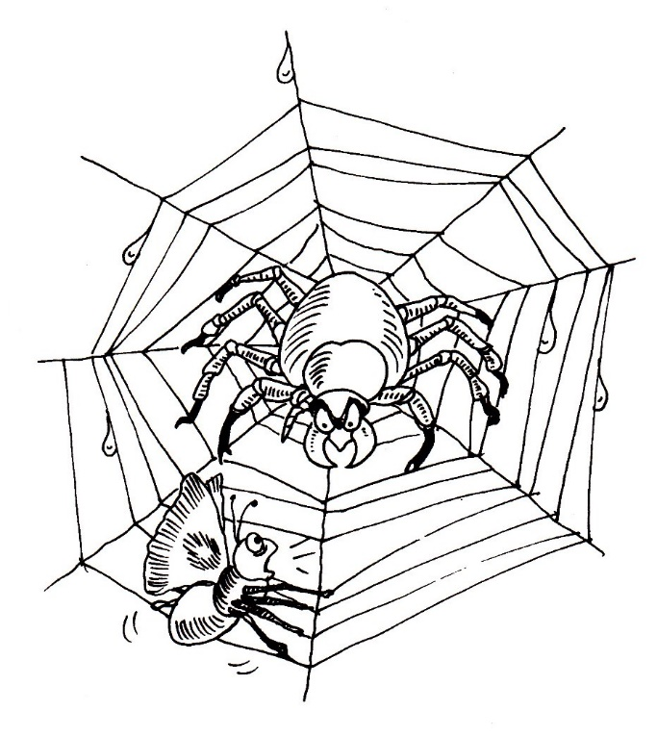
Spiders
Poem
Spider, spider climbing the wall,
You’re the most frightening of all.
Spider, spider hanging in the tree,
Please, oh please, don’t crawl on me.
Spider, spider high above the ground,
Spinning your silk web round and round.
Spider, spider resting on my knee, I won’t hurt you, so don’t hurt me.
Spider, spider be my friend,
So we can live to a happy end.
1. Write words from the poem that sound like:
all ___________________
tree ___________________
ground ___________________
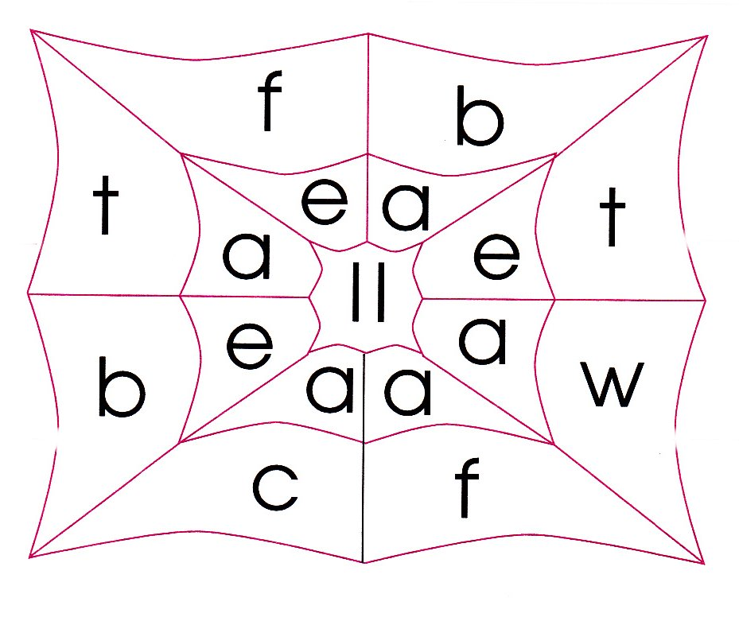
2. Combine the letters of the word web to write a word bank.

____________________
____________________
____________________
____________________
____________________
______________________________________________________________________________________________________________________________________________________

