What is a Rainforest?

A rainforest is a cool, green, quiet place. Lots of plants and animals live in the rainforest.
You will find lots of tall trees there. The tall trees get all of the sunlight. The small trees do not get much sunlight. The small trees do not grow well.
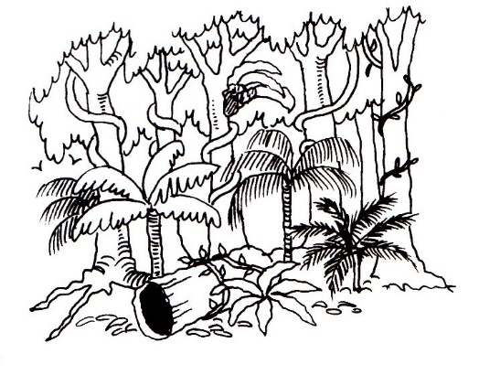
There are lots of animals like the tree kangaroo, possums, bats, birds, frogs and lizards that live in the rainforest.

Yes or No?
1. It is very hot in the rainforest. ______________________
2. Small trees do not get much sunlight. ______________________
3. Bats live in the rainforest. ______________________
4. Polar Bears live in the rainforest. ______________________
5. There are not many plants in the rainforest. ______________________

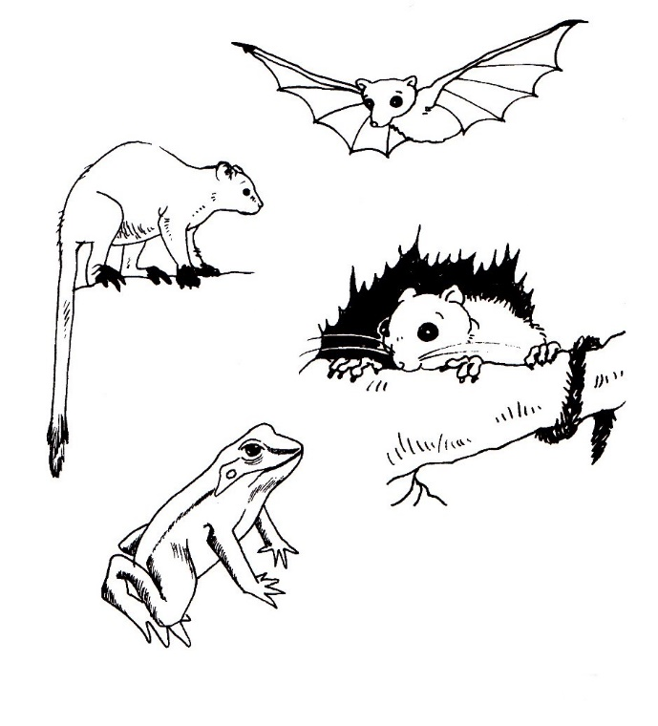
Match the picture of the animal to its name.
- tree kangaroo
- possum
- fruit bat
- leaf-green tree frog

