Monday 6th Sept . Stage 2 Term3
Question 1:

Underline the pronouns in the text extracts eg he, she, it, they
The rat knew that he was on the right path! The path stretched through the city over the hills. It was covered in rocks and grass. He was feeling tired but marched on.
Honey is a delicious ingredient in cake and stir-fry, but it is also tasty on bread or in tea.
Tyler rode his skateboard down the road towards the skate park. His helmet was firm on his head, and he moved the straps so they wouldn’t hit him.
If we send you something today, please make sure you reply to me by Thursday next week.
After the rains, when saplings are springing up everywhere, a fox comes into the bush, Fox with his haunted eyes and rich red coat. He flickers through the trees like a tongue of fire, and Magpie trembles.
Fox by Margaret Wild, Illustrated by Ron Brooks, 2004, Allen and Unwin
Rose’s best friend Olive’s mother, Karrang, makes beautiful coloured baskets, mats and bags from leaves from the pandanus palm a tall, thin tree with very long, spiky leaves. Rose and Olive spend a day out bush helping to gather the pandanus leaves and stringy bark for making into strong bags and baskets. They collect the colour that the bags will be bright yellows and pinks, from special plants and berries. It is a hard day’s work for Rose, but the results are worth it.
Collecting Colour by Kylie Dunstan, 2009, Lothian Children’s Books

Tuesday 7th Sept Stage 2 Term 3
Question 2:
Read the text then answer the question. Answer as many as you can.
George’s Marvellous Medicine  Roald Dahl, Puffin Books, 1981  In the kitchen, George put the saucepan on the stove and turned up the gas flame underneath it as high as it would go.  ‘George!’ came the awful voice from the next room. ‘It’s time for my medicine!’  ‘Not yet, Grandma,’ George called back. ‘There’s still twenty minutes before eleven o’clock.’  ‘What mischief are you up to in there now?” Granny screeched. ‘I hear noises.’  George thought it best not to answer this one. He found a long wooden spooning a kitchen drawer and began stirring hard. The stuff in the pot got hotter and hotter.  Soon the marvellous mixture began to froth and foam. A rich blue smoke, the colour of peacocks, rose from the surface of the liquid, and a fiery fearsome smell filled the kitchen. It made George choke and splutter. It was a smell unlike any he had smelled before. It was a brutal and bewitching smell, spicy and staggering, fierce and frenzied, full of wizardry and magic. Whenever he got a whiff of it up his nose, firecrackers went off in his skull and electric prickles ran along the backs of his legs. It was wonderful to stand there stirring this amazing bubbling mixture and to watch it smoking blue and bubbling and frothing and foaming as through it was alive. At one point, he could have sworn he saw bright sparks flashing in the swirling foam. | What do you think the words in boxes mean?  eg as high as it would go -very high.  awful voice – terrible voice

Wednesday 8th September Stage 2 Term 3
Question 3: Read the text about Earthworms.

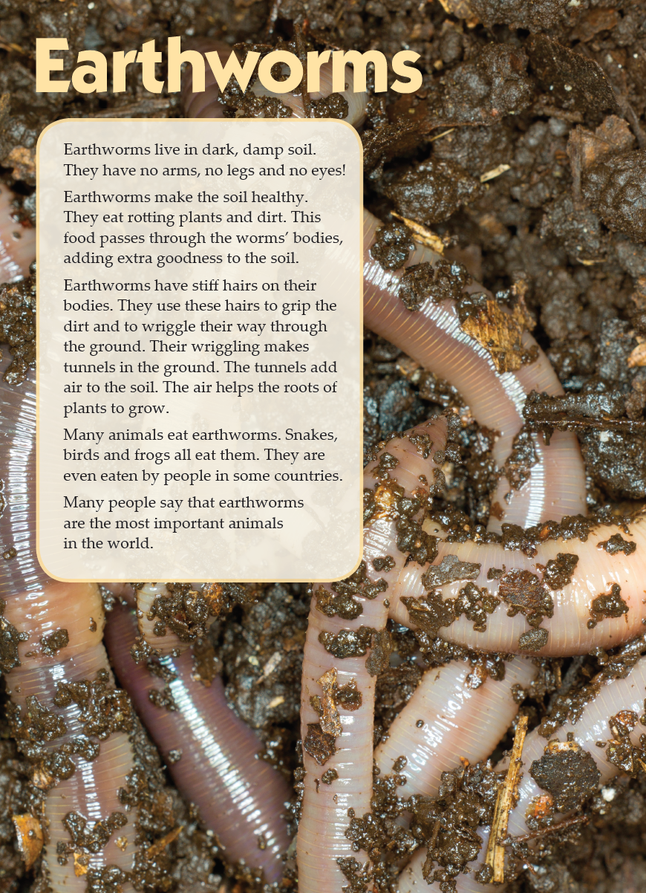
What are the 5 most important facts about earthworms? The first one has been done for you.

- Earthworms live in dark, damp soil.

- Earthworms

- Earthworms

- They

- They

Thursday 9th September Stage 2 Term 3
Question 4: A fact is a statement that is true… F or it could be an opinion ( something that you think is true….. O). Now circle F or O in each box.

Healthy eating
Peaches are not the best choice for the dessert because they are sour. F / O | Sunflower kernels are a delicious afternoon snack.  F / O
Raspberries are full of antioxidants and are a healthy food choice. F / O | There are a range of milk options including cow, almond, soy and oat. F / O
Almost half of children aged 2-15 years ate the recommended daily amount of vegetables  (healthykids.nsw.gov.au) F / O | Anything cooked in oil is bad for you and you should not eat it at all. F / O
Kakadu plums contain 100 times more Vitamin C than oranges. F / O | Of adolescents in Years 6, 8 and 10, about a third ate confectionary at least three times a week. F / O
We are so lucky to live in a country where we have so many different foods, like Chinese, Thai, Indian and Middle eastern. F / O | The cashew nut can be eaten both raw and cooked.  F / O
Fatty fish such as mackerel and salmon are rich in omega-3 fatty acids. F /O | The Mediterranean diet blends healthy eating with traditional flavours and cooking methods found in the Mediterranean region. F / O
Brussel sprouts are definitely not used enough – cooked in the right way, they are delicious. F / O | Water is the best drink to quench your thirst.  F / O

