Dalmeny Public School
Enrolment Policy - 2023

Approved by: Ms Emma Jamieson (Principal)
Approval date: 8th August 2023

Brief Description:
The Enrolment of Students in NSW Government Schools policy is in place to assist schools to meet their obligations under the Education Act 1990 - to ensure that every student has a place at their local school. The policy also communicates to staff and the community a transparent enrolment process.

Contents
1. Introduction 2
2. Audience and application 3
3. Responsibilities and delegations 4
4. Out of Area Enrolment Applications 5
5. Monitoring, evaluation and reporting requirements 6
6. More information 6
7. Terms and definitions 6
Appendix 1 7
Appendix 2 8

Introduction
  - This document provides information for the community and direction for school personnel on the entitlements, requirements and procedures for the enrolment of students at Dalmeny Public School. Parents may seek to enrol their child in the school of their choice.
  - Every child within the Dalmeny Public School intake area is entitled to enrol at their local school. Placements for local students are ensured. Dalmeny Public School may accept out of area enrolments. Such enrolments are subject to availability of positions, the school’s enrolment cap, selection criteria, NSW Department of Education Enrolment Policy and this policy. Out of area placements will not be available where in area enrolments exceed recommended class enrolment ceilings and the school’s enrolment cap.
  - All NSW Public Schools are required, by the NSW Department of Education to set an enrolment ceiling to cater for anticipated local demand in order to ensure that every eligible local child has a place at his or her local school if he or she chooses to attend it.
  - School Locator: To confirm your local school the NSW Public School Finder website is available https://schoolfinder.education.nsw.gov.au/
  - Enrolment Applications: Online enrolment program is being trialled for all Public Schools, to apply online your child must be; a NSW resident; an Australian or New Zealand citizen or permanent resident, and; living in the local enrolment area of the school for which you are submitting an application.

Audience and application
  - This policy applies to all local and out of area enrolments for Dalmeny Public School.
  - Enrolment Ceilings- Dalmeny Public School has permanent building accommodation for 22 classes with an enrolment ceiling of 555 students.
The recommended class ceilings are 20 students for Kindergarten, 22 students for Year 1 and 24 students for Year 2.
In combined class groupings such as Kindergarten and Year 1 the student ceiling is 20, Year 1 and Year 2 the student ceiling is 22 and Year 2 and Year 3 the student ceiling is 24.
Demountable buildings are not included in determining enrolment ceilings unless permanent replacement accommodation is under construction.

Once the school has reached their enrolment cap, set by the NSW Department of Education and based on permanent classroom buildings Dalmeny is unable to offer placement to out of area students, including siblings.
  - Enrolment Buffer- No additional accommodation (permanent or demountable) will be provided to cater for an increased enrolments resulting from out of areas enrolments. Two classroom positions must be held for incoming local placements. This means that once:
Kindergarten classes reach 18 students;
Year 1 classes reach 20 students;
Year 2 classes reach 22 students;
Combined Kindergarten and Year 1 classes reach 18 students;
Combined Year 1 and Year 2 classes reach 20 students and
Combined Year 2 and Year 3 classes reach 22 students;
If classes are at the above capacity, with the local enrolment buffer in place this means that no out of area placements can be accepted.

Responsibilities and delegations
  - The principal is responsible for: preparing an out of area enrolment policy in consultation with the school community; advising the Director of Educational Leadership of out of area enrolments and trends at school; maintaining accurate and complete out of area enrolment data; setting an enrolment number to manage out if area applications and enrolments; establishing a placement panel when demand for out of area places exceeds available accommodation.
  - The Director of Educational Leadership is responsible for; monitoring enrolment policies, procedures, numbers and enrolment caps at Dalmeny Public School; making determinations for out of area placements which cannot be resolved at a school level; monitoring Dalmeny Public School’s out of area enrolments and trends in collaboration with the principal.
  - Where out of area applications exceed position availability, the school will establish a placement panel to consider and make recommendations on all out of area enrolments.

Out of Area Enrolment Applications
At Dalmeny Public School our enrolments are high, exceeding our enrolment ceiling of 555 students with our local enrolment. Out of Area applications are available for the community however are subject to policy and procedures of the Department of Education.

  - Out of Area enrolment applications are assessed by our Enrolment Committee which consists of school and P&C representatives. The committee meets at least once a term to assess and respond to Out of Area applications. The committee assesses individual applications against the DoE policy, enrolment cap and considerations may be made if deemed in a child’s best interest in areas of health, wellbeing and safety. The panel must be chaired by a senior executive (Deputy Principal), at least one staff member and a community representative. In assessing an out of area application, the panel will consider only those matters presented on the out of area application form. Oral or other submissions will not be considered. The panel will consider the criteria for acceptance such as:
a) Enrolment cap
b) Enrolment buffer
c) Student welfare
d) Student health
e) Student safety
f) Sibling applications are assessed regarding student wellbeing, consideration of safety and supervision before and after school and/or compassionate circumstances including but not limited to medical reasons.

4.2 Appeals against the decision of the placement panel may be lodged in writing with the principal in cases where a parent or caregiver feels the stated criteria have not been applied fairly. The principal will seek to resolve the matter. If the matter is not resolved at the school level the Director of Educational Leadership will consider the appeal and make a determination.

Monitoring, evaluation and reporting requirements
  - Dalmeny Public School, Principal and enrolment committee, will monitor the implementation of this policy and review its effectiveness, every three years and/or as required. Identify who is responsible for monitoring, evaluation and reporting.

More information
  - Dalmeny Public School Principal- Ms Emma Jamieson Phone: (02) 9826 9033

Terms and definitions
e.g. Department means the NSW Department of Education.

Appendix 1
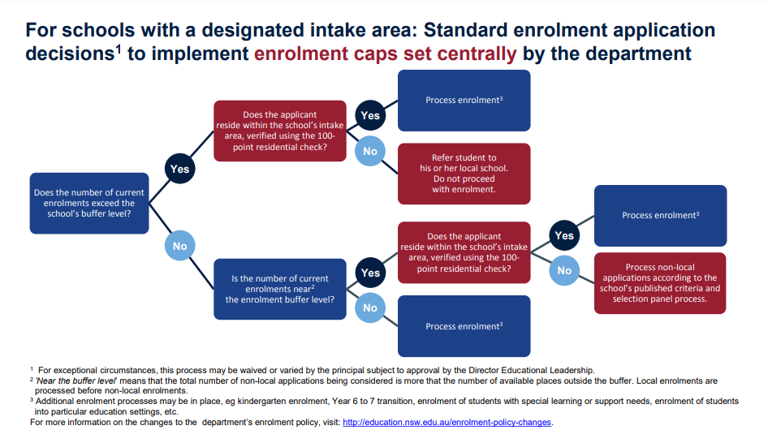

Appendix 2
